Smart Belt for Visually Impaired People

Minhazul Billah, Zulker Nayen, Nushrat Jahan, Farisha tabassum

[minhazbillah@gmail.com](mailto:minhazbillah@gmail.com), [zulkernayen75@gmail.com](mailto:zulkernayen75@gmail.com), [farishatabassum90@gmail.com](mailto:farishatabassum90@gmail.com)

TABLE OF CONTENTS

Chapter 1: Table of contents 1

Chapter 2: Abstract 2

Chapter 3: Introduction 2-4

Chapter 4: related works 4-6

4.1: #

4.2: #

4.3: #

4.4: #

4.5: #

4.6: #

4.7: #

4.8: #

4.9: #

4.10: #

4.11: #

chapter 5: Proposed system 2

chapter 6: block diagram 2

chapter 7: system architecture 2

**7.1: Ultrasonic sonar sensor #**

**7.2: Arduino Uno #**

**7.3: raspberry pi #**

**7.4: headphone/speaker #**

**7.5: power source #**

chapter 8: flowchart 2

chapter 9: performance Evaluation 2

chapter 10: working process 2

chapter 11: conclusion 2

chapter 12: references 2

Figures:

**1: hardware architecture #**

**2: Block Diagram of Obstacle Detection System #**

**3: Ultrasonic sonar sensor #**

**4: Arduino Uno #**

**5: Raspberry Pi #**

**6: flowchart #**

**7: working of an ultrasonic sensor #**

# 

# 

# **Abstract:**

People without vision face many difficulties in their day to day life mostly while dealing with physical movement which often results in risky situations. With a rapid growth of transportation in Bangladesh, accidents are occurring more frequently .Blind people are the innocent victims of road accidents in most cases. In order to assist blind people for their navigation there are many smart devices. As these cooperating devices are expensive, most people cannot afford it let alone being assisted by the devices. Moreover some devices cause hustle too. With a view to solving the issues, we have come up with a better solution which will provide easiness to use and wear the device (Smart Belt) and proper guidance for secure movement .Our smart belt consists of many features. Firstly, it is a wearable device, it’s like smart belt which has an ultrasonic sonar sensor [7.1] attached to the belt. Secondly,it will detect an object on the path of the user [6]. Thirdly, it will calculate the distance [9] and generate sounds by the help of Arduino and Raspberry pi [8]. Finally, according to the detection it will pass sound through headphones which will guide the user to a safer destination. It is low cost and easily wearable smart belt for a blind person.

Keywords—Arduino; Raspberry pi; Ultrasonic sensor; Blind person

# **Introduction:**

Specialists at a discourse have said around 750,000 individuals in Bangladesh are experiencing visual impairment while roughly 253 million individuals on the planet live with moderate to extreme vision disability. Out of 253 million vision hindrance, 36 million individuals are visually impaired. National Eye Care under the Service of Wellbeing and Family Welfare sorted out the discourse in the city as a major aspect of the countrywide recognition of the World Sight Day with the topic "Eye Care All over the place,'' said an official statement. Executive of National Eye Care Line and National Establishment of Ophthalmology and Emergency clinic (NIOH) Dr. Golam Mostafa while showing his keynote paper at the exchange stated: "Around 1.5 million youngsters in Bangladesh are experiencing low vision, which can be dodged through intercession while around 250,000 individuals in Bangladesh hazard losing visual perception on account of diabetic retinopathy." Head administrator's Worldwide Undertakings Guide Gowher Rizvi tended to the dialog as the main visitor. Previous wellbeing and family welfare undertakings counselor to the head administrator Dr. Syed Modasser Ali, Asia Pacific Foundation of Ophthalmology VP Dr. Ava Hossain and Ophthalmology Society of Bangladesh President Dr. Sharfuddin Ahmed were available as the exceptional visitors. About 89% of the vision impeded individuals live in low and center salary nations, the speakers said. As indicated by the eye wellbeing specialists, waterfall is the primary purpose behind vision hindrance while refractive blunders, diabetic retinopathy and youth visual impairment are additionally in charge of it. They said around 80% of visual impairment is avoidable by intercession. [4.7]Akhila S, Divyashree. D, Disha M Rani, Varshini. S. S (2016) proposed a paper about a brilliant stick framework idea is conceived to give a shrewd electronic guide to visually impaired individuals. Visually impaired and outwardly weakened individuals discover troubles in recognizing snags while strolling in the road. The framework is proposed to give counterfeit vision and item discovery, ongoing help by means of GPS by utilizing Raspberry Pi. The framework comprises of ultrasonic sensors, GPS module, and the input is get through sound, voice yield works through TTS (content to discourse). The proposed framework recognizes an article around them and sends criticism as discourse, cautioning messages by means of headphones and furthermore gives route to explicit area through GPS. The point of the general framework is to give a minimal effort and effective route and impediment location help for visually impaired which gives a feeling of counterfeit vision by giving data about the ecological situation of static and dynamic item around them, with the goal that they can walk autonomously. [4.8]Dr. B. Muthusenthil, Kishore. S, Joshwa j, Narendiran K (2018) in the paper tends to the combination of a total Content Read-out framework intended for the outwardly tested. The framework comprises of a webcam interfaced with raspberry pi which acknowledges a page of printed content. The OCR (Optical Character Acknowledgment) bundle introduced in raspberry pi checks it into an advanced report which is then exposed to slant redress, division, before highlight extraction to perform order. When ordered, the content is readout by a content to discourse transformation unit (TTS motor) introduced in raspberry pi. The yield is bolstered to a sound intensifier before it is perused out. The reproduction is only a commencement of picture preparing for example the picture to content transformation and content to discourse change done by the OCR programming introduced in raspberry pi. The framework finds intriguing applications with regards to libraries, assembly halls, workplaces where directions and notification are to be perused and furthermore in the helped filling of use forms. By utilizing ultrasonic sensor we will gauge the separation between the visually impaired individuals and snag then the separation will be played through ear telephones. [4.9] Shiyam, Raghul. M, Surender. K, Ms. R. Hemalatha was tending to the issues of Individuals with Visual, Hearing and Vocal Disability through a solitary helping framework is an extreme occupation. Numerous cutting edge investigates center around tending to the issues of one of the above difficulties yet not all. The work focuses on finding a unique technique that aids the visually impaired by letting them hear what is represented as text and it is accomplished by the method that catches the picture through a camera and changes over the content accessible as voice signals. The paper gives a route to the general population with Hearing weakness to picture/reREad which is in sound structure by discourse to content transformation procedure and we likewise gives a path to the vocally impeded to speak to their voice by the guide of content to voice change method. All these three arrangements were regulated to be in a solitary one of a kind framework. Every one of these exercises are facilitated with the utilization of Raspberry Pi. The outwardly impeded individuals are helped by the procedure where the picture to content and content to discourse is given by the Tesseract OCR (online character acknowledgment). The hard of hearing individuals help with the procedure of an application which makes them to comprehend what the individual says can be shown as the message. Vocally impeded individuals can convey their message by text so the other person can hear the message in a speaker. [4.11] Anoush Goel, Akash Sehrawat, Ankush Patil, Prashant Chougule, Supriya Khatavkar (June, 2018) introduces the programmed report per user for outwardly hindered individuals, created on Raspberry Pi. It utilizes the Optical character acknowledgment innovation for the recognizable proof of the printed characters utilizing picture detecting gadgets and PC programming. It changes over pictures of composed, written by hand, or printed content into machine encoded content. In this examination these pictures are changed over into the sound yield (Discourse) using OCR and Content to-discourse combination. The transformation of printed report into content documents is finished utilizing Raspberry Pi which again utilizes Tesseract library and Python programming. The content documents are handled by OpenCV library and python programming language and sound yield is accomplished.

# **Related Work:**

# As we were searching for the papers related to our work. We found that there are many ways to help the blind people in need.

**4.1**

One of the papers is Advanced Audio Aid for Visually Impaired Using Raspberry Pi (International Journal of Innovative Research in Advanced Engineering (IJIRAE) ISSN: 2349-2163 ,Issue 04, Volume 4 (April 2017) ) article by B.P. Vinknesh, E. Annadevi, V. Pavithran ,we found that they have used raspberry pi, ultrasonic sensor, viola-jones for face detection as it has been programmed in a way where it will detect face , lbp for comparing each pixel of an image with its neighborhood, also random-forest classifier which produce large number of decision tree on random data and random selection of variables to find things and also surf for object detection and image classification. A few components and some of the work process matches with our project. We are also using raspberry pi and ultrasonic sensor in our project for detecting any obstacle in front of the blind man and in addition also using an Arduino Uno.

**4.2**

In another project Hand-Held Object Recognition for a Blind Using Raspberry Pi (The International Journal Of Engineering And Science (IJES) || Volume || 5 || Issue || 4 || Pages || PP -60-64 || 2016 || ISSN (e): 2319 – 1813 ISSN (p): 2319 – 1805 ) by Aabi A. Dhivyalakshmi T. Joan Kanishka S. Ms.S.Jaipriya where they use raspberry pi 2,camera, spectacle, python, Bluetooth earphone, audio jack. In this the blind people is able to use the camera on their spectacle, when the object is captured its get compared with the histogram of image in the MATHLAB. So to find the histogram they had to use gray scale image and followed with lbp algorithm which convert gray scale image into lbp code image then it gets converted into speech output, the audio jack which is connected raspberry pi helps with the speech output and in the end by connecting Bluetooth earpiece at the audio jack the blind man can hear the speech.

However if we compare our projects we only have some similar components such as Raspberry Pi 3,python,normal earpiece but our whole process is different from them .We are building an obstacle detection belt for blind man using an ultrasonic sensor and many other components.

**4.3**

Also in another paper is Real Time Collision with Raspberry Pi for Blind Person using Image processing (International Journal of Innovations & Advancement in Computer Science IJIACS ISSN 2347 – 8616 Volume 6, Issue 10 October 2017) by Praveena P. Bhitale., Shilpa S. Chavan., Sanjyoti S. Devrukhakar, Santosh V. Jadhav. , in their paper they tried to do real time collision prediction using a camera with raspberry pi and image processing to help blind people in moving and allowing them to identify the presence of objects in the visual scope of the user for safe journey. However by comparing it with our project only one component matches which is the raspberry pi from which an ultrasonic sensor is connected by an Arduino that help to detect the obstacle in front of a blind man in daily life.

**4.4**

Adding to it, from another paper called Hardware Implementation of Smart Reader for Visually Impaired People Using Raspberry PI (International Journal of Advanced Research in Electrical, Electronics and Instrumentation Engineering (An ISO 3297: 2007 Certified Organization)Vol. 5, Issue 3, March 2016 ) by Velmurugan.D, Srilakshmi, Umamaheswari.S, Parthasarathy. S, Arun. K.R ,this work proposes a smart reader for visually impaired people using raspberry pi where the coding was done by python language ,also this system consists of a webcam interfaced with MATLAB with the help of image processing toolbox OCR and an audio amplifier in it. Through comparing it with our project only few components matches but the idea of the project is completely different from ours. In our project we are using raspberry pi, ultrasonic sonar sensor, USB cable, Arduino, SD card and many more component for building a smart belt for visually impaired people so that they can use it for obstacle detection in their day to day life.

**4.5**

In the process of studying we found in Obstacle Detection for Visually Impaired Using Raspberry Pi and Ultrasonic sonar Sensors (National Conference on Product Design (NCPD 2016), July 2016 by Ayush Wattal, Ashutosh Ojha, Manoj Kumar they have used raspberry pi and ultrasonic sensors to guide a blind person as we did they have successfully implemented those parts and guided a blind man perfectly. They also configured their project to guide a blind person on moving left right or for going backward. In this project they processed the data coming from ultrasonic sonar sensor by a raspberry pi where we have done it through an Arduino Uno microcontroller to get proper results and to stay away from a few glitches.

**4.6**

Also in another project named WIRELESS SENSOR BASED GPS MOBILE APPLICATION FOR BLIND PEOPLE NAVIGATION(ARPN Journal of Engineering and Applied Sciences, VOL. 11,NO. 13, JULY 2016) article by Sunaina Vasireddy, Vyshnavi Ravipati, T. Ravi and G. Jegan, they have used an ultrasonic sonar sensor, Temperature sensor, Mems sensor, LDR and an Android app with a headset to guide a blind person where we have used just an ultrasonic sonar sensor, an Arduino Uno and a raspberry pi to process data and guide a blind person.

**4.7**

We also found another project named Smart Stick for Blind using Raspberry Pi (International Journal of Engineering Research & Technology,Volume 4, Issue 22,2016,ISSN: 2278-0181) article by Akhila. S, Divyashree. D,Disha m Rani, Varshini.S.S they have used an ultrasonic sensor, Raspberry Pi, GPS Module and Earphone to guide the blind person with proper navigation where we have used just an ultrasonic sonar sensor, an Arduino Uno and a raspberry pi to process data and guide a blind person. We used Arduino for flexibility in our belt and to get accurate data where their smart stick is heavier hard to walk and often GPS fails to work.

**4.8**

Moreover, in another article named Smart Assistance for Blind People using Raspberry Pi (Muthusenthil. B et.al; International Journal of Advance Research, Ideas and Innovations in Technology,Volume 4, Issue 2,ISSN: 2454-132X ,2018) article by Dr. B. Muthusenthil,Kishore S,Narendiran K, Joshuva J they used Raspberry Pi, Web Cam, Optical Character Recognition, Text to Speech Engine, Audio Amplifier and built and assistant that helps the blind person to read the text from any books, articles ,journals and etc where we have used just an ultrasonic sonar sensor, an Arduino Uno and a raspberry pi to process data and guide a blind person properly and without facing any accident.

**4.9**

Furthermore, In another article we found a project named Raspberry-Pi Based Assistive Device For Deaf, Dumb And Blind People article written by ShiyamRaghul.M, Surendhar.K, Suresh.N, Ms.R.Hemalatha they used Raspberry-Pi ,Assistive device, Tesseract optical character recognition OCR, E Speak, OpenCV, Google API by using this things they made a device which they can assists blind, deaf and dumb people to cope-up with others where we have used just an ultrasonic sonar sensor, an Arduino Uno and a raspberry pi to process data and guide only blind people.

**4.10**

In a paper named Innovative Wearable Navigation Device for the Blind Using Raspberry Pi (International Journal of Advanced Research in Computer Science and Software Engineering|| ISSN: 2277 128X || Volume || 6 || Issue || 3 || March 2016 ) by Ravel, Y where he proposed an undertaking to build up an electronic route framework for outwardly disabled, that utilizes sensors for deterrent discovery. Individuals who are outwardly hindered battle each day in performing activities that can be as straightforward as moving starting with one point then onto the next without tumbling down or thumping against hindrances. An Electronic Travel Help (Estimated time of arrival) is a type of assistive innovation having the motivation behind upgrading versatility for the visually impaired and outwardly weakened (VI) person on foot. Assistive gadgets intended to help outwardly impeded individuals need to manage two unique issues: from the outset they have to catch logical data pursued by their need to impart to the client with those watched data. Sensors are conveyed for hindrance recognition. The ongoing sign reflected from the snags is gathered by the sensor and Raspberry pi Board forms the sign. In view of the prepared information, suitable choice is taken by the Raspberry pi in it. As needs be a significant message is conjured from the blaze memory. An installed framework is a registering limitations.

**4.11**

Another paper, Raspberry Pi Based Reader for Blind People (International Research Journal of Engineering and Technology (IRJET) || e-ISSN: 2395-0056 || p-ISSN: 2395-0072 || Volume|| 05 || Issue || 06 || June-2018) by Goel,.A.,Sehrawat,.A., Patil,.A., Chougule,.P. and Khatavkar, S. introduces the programmed archive per user for outwardly weakened individuals, created on Raspberry Pi. It utilizes the Optical character acknowledgment innovation for the recognizable proof of the printed characters utilizing picture detecting gadgets and PC programming. It changes over pictures of composed, written by hand, or printed content into machine encoded content. In this exploration these pictures are changed over into the sound yield (Discourse) using OCR and Content to-discourse blend. The change of printed archive into content documents is finished utilizing Raspberry Pi which again utilizes Tesseract library and Python programming. The content documents are handled by OpenCV library and python programming language and sound yield is accomplished.

# **Proposed System:**

With a view to assisting to the people who don’t have visions, we are proposing a model which will be using two microcontrollers such as Arduino Uno and Raspberry Pi Model 3b+ for accomplishing dedicated tasks. Moreover, an (HC-SR04) Ultrasonic sensor is used in order to detect any kind of obstacle or barrier within the path of the blind passersby. The sensor sends a signal from the Arduino board to the Raspberry Pi Computer whenever it can detect an obstacle. In addition to this, there will be a voice output which will be generated by the Raspberry Pi regarding the obstacle in the surroundings through a headphone to the users and will be the guideline for them. After getting the voice alert and being aware of the dangers, the possibilities of endangering a blind person's life can be lessened.

## 

## **Block Diagram of Proposed System:**

## 

**Figure-1. Hardware architecture**

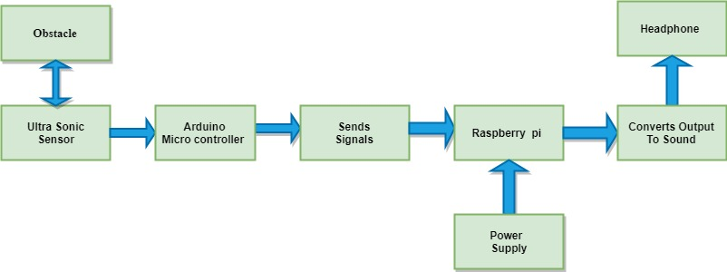

**Figure-2.Block Diagram of Obstacle Detection System**

### **System architecture:**

**Ultrasonic Sonar Sensor:**

The Ultrasonic Sensors has a place with a classification of sensors that produces ultrasound for example sound of recurrence in excess of 20 KHz. At first, a trigger heartbeat is given as a contribution to the ultrasonic sensor utilizing Arduino. The ultrasonic sensor at that point emanates a short 40 kHz ultrasonic burst signal. This burst sign goes through the air at roughly 343ms-1, hits an item and after that skips back to the sensor bringing about a yield beat. This yield heartbeat is caught by Raspberry Pi. By using that time taken by the pulse to return we measured the distance from the obstacle. The sensor has four pins: (1) VCC, (2) Trigger, (3) Echo and (4) Ground.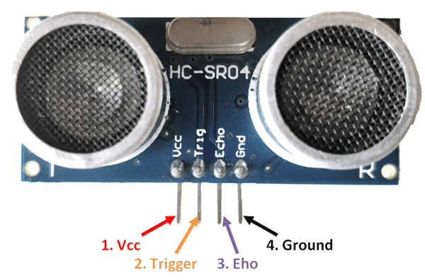**Figure: 3**

**Arduino Uno:**

Arduino is an open-source electronic gadget dependent on simple to-utilize equipment and programming. Arduino sheets can peruse inputs - light on a sensor, a finger on a catch, or a Twitter message - and transform it into a yield - actuating an engine, turning on a LED, distributing something on the web. You can guide your board by sending a lot of guidelines to the microcontroller controller on the board. In our system we attached the microcontroller to Ultrasonic Sensor. We attached the pins in this way: 1.VCC to Arduino Vin. 2. GND to Arduino GND. 3.Echo to Arduino pin 12. 4. Trig to Arduino pin 11. Arduino measures the data and send the data to Raspberry Pi.

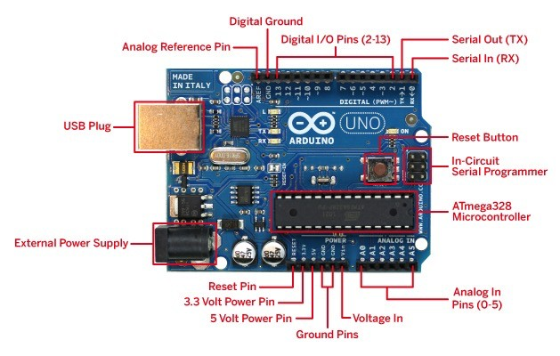

**Figure-4.Arduino**

**Raspberry Pi:**

Raspberry Pi small board, low priced computer it takes input from the GPIO pins, which may be connected to LEDs, switches, analog signals and alternative devices. For our planned style, we tend to connect the GPIO pins to the sensors. It needs an influence supply of 5V to be operational and needs a memory card in it, which acts as its permanent memory. For our style Raspberry Pi three model B+. It contains four USB ports, a HDMI port, an audio jack port and a LAN port.

This microcontroller receive data from the Arduino and helps us send a voice message through the headphones. This voice is send by computing all the data this work is fully handled by raspberry pi. For programming we used python.

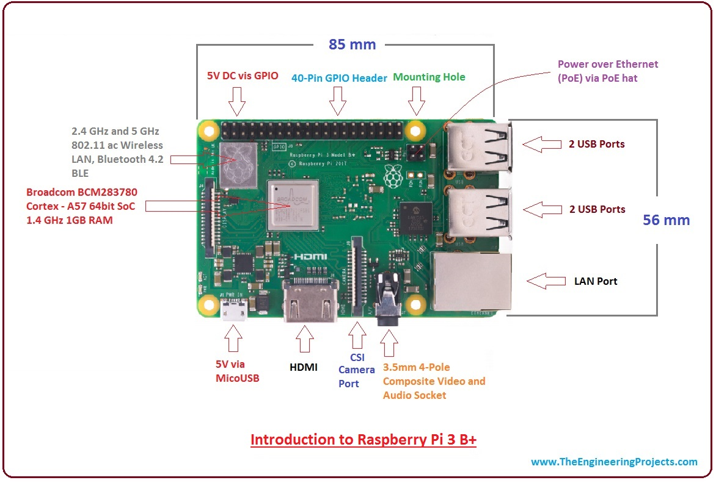

**Figure: 5**

**Headphone/Microphone:**

Headphone/Microphone is used for making the blind person aware of the obstacles which is coming toward him, by sending a voice message for the obstacle. It is better than a buzzer, sound helps the person to easily react.

**Power supply:**

This system requires a 5V power supply. For that we can use a battery, portable charger, power bank.

**Flowchart:**

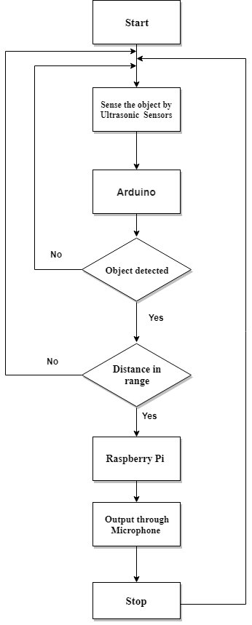**Figure: 6**

**Performance Evaluation:**

Ultrasonic sensors are used for obstacle detection and calculation of distance between the obstacle and the visually impaired person. Ultrasonic sonar sensors are used in pair as transceivers [9] [10] i.e. a single sensor can both send and receive signals. The transmitter emits eight 40 kHz pulse, this pulse after hitting the obstacle is received back at the receiver, as shown in Fig. 4. The ultrasonic sensor works on the principle of sonar [15] i.e. it records the time taken by the emitted pulse to return back at the receiver end. Our algorithm implemented in Python programming language is deployed on Raspberry Pi. This algorithm is used to calculate the distance between the obstacle and the person, by recording the time interval between the pulse sent and pulse received. In this setup we use 3 ultrasonic sensors, which help the person to find any obstacle in left, right or front direction.

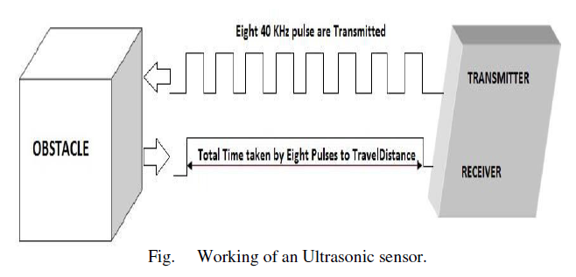

**Figure: 7**

Distance Calculation

To find the distance between the obstacle and the person,

We use Distance Formula: distance = speed * time

OD = {[Speed of Sound * Time Taken] / 2} (1)

Where, OD: Distance between an obstacle and the person in meters. Speed of Sound: We take speed of sound as 343 meter/sec. Time Taken: It is the time interval between the pulse emitted and the pulse received.

An electronic device is built in the form of a Raspberry Pi Belt to detect obstacles. The device is tested, by placing various obstacles at front positions and distances from the sensors on the belt. The system is successful in warning the user about the presence of obstacles in their path. It can detect any object within a pre-specified minimum distance in any direction. For out tests, we set the minimum distance. The system announces the distance calculated in real time in meters or centimeters. For the simplicity of the user, the audio messages are stored in the form on Raspberry pi. The distance calculated based on the receiving pulse (echo) is not hundred percent accurate, however, we take into account the worst case and thus provide with the best results to avoid the obstacle.

**Working Process:**

* When the cooperating smart belt is activated, it is capable of detecting objects from the surroundings
* The ultrasonic sensor contribute to detect any obstacle
* Then the sensor passes signal to Arduino
* The Arduino Uno verifies If any obstacle is detected or not
* It is checked also if the obstacle is within range or not
* If the detected obstacle is located within the range of the sensor, then the Arduino sends the data to another microcontroller Raspberry Pi otherwise the obstacle detecting process is started by the beginning
* Then the data is processed and a voice output is generated by Raspberry Pi and sent to the user through a connected headphone and thus the process concludes.

**Conclusion:**

To sum up, the purpose of our chosen work is to serve the people who are sightless or possess ill vision which can be considered as a humanitarian work. We belief that by our little effort mentioned in this paper, we can be a helping hand to others who need it badly. Besides, we have attempted to keep the cost of this assistant belt reasonable. In addition to this, we are thinking of earning more efficiency by adding accurate navigation system which can provide guidance to the user for reaching the destination safely. Thus, there can be some backsides of our design which are hoping to cope up with better ideas which need to be implemented in the future.

**References:**